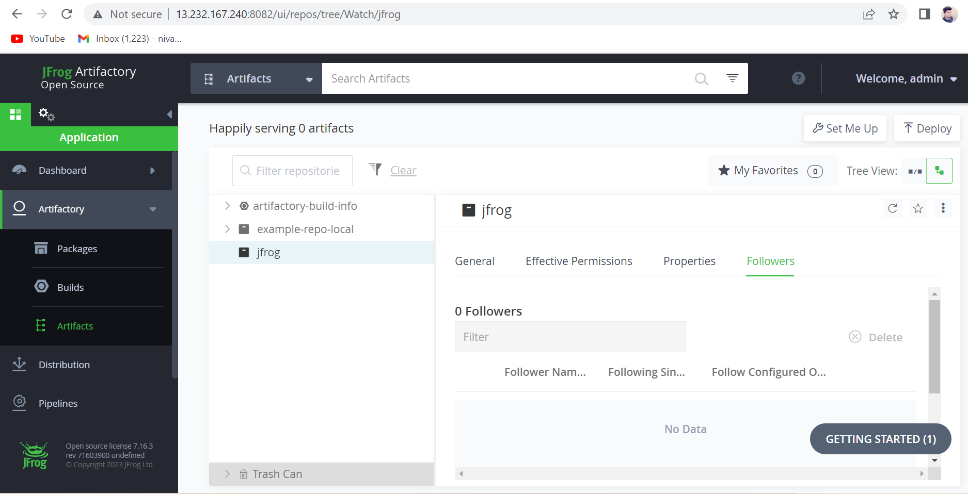

1. Jfrog Artifactory Open-Source server is Configured in Amazon Linux machine.
2. Next, Created a New JFROG Repo in Artifactory.
3. Repo Configuration details below.

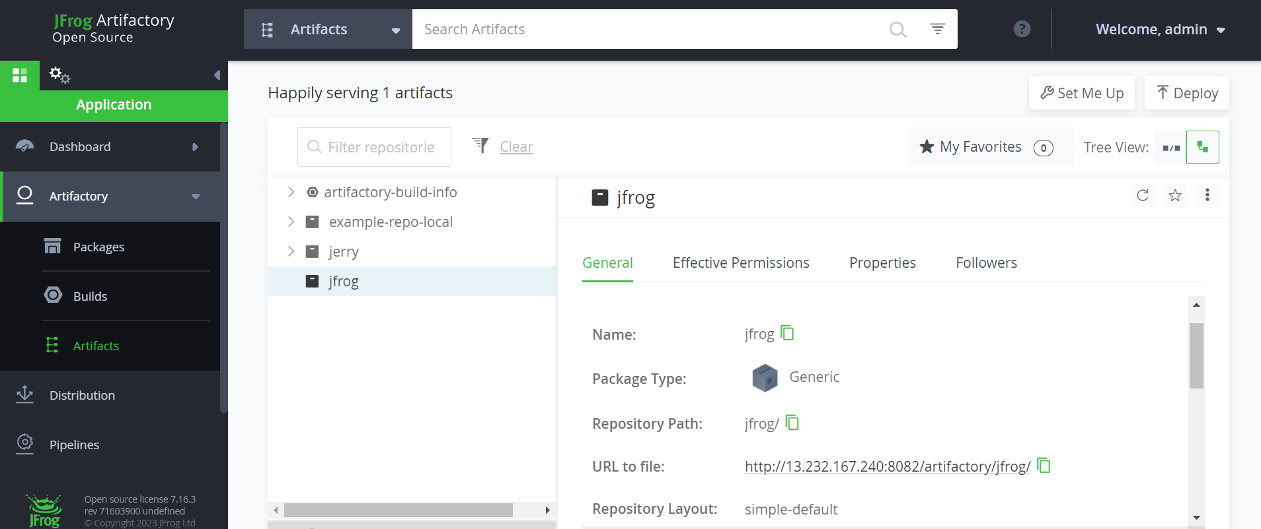

1. In Jenkins, we created a New Project with name of **Onetest**.

**Find the Below Configuration Steps of Jenkins with GitHub & Jfrog.**

1. **Added the Github repo Url in given path.**
2. **All the next configurations steps as Normal.**
3. **Give some name to the Build step as per the below pic.**

1. **Set us Run Only if build succeeds option in the given panel.**
2. **Next, In post build stage deploy artifacts requirements.**

1. **Next, just apply and save the given progress.**
2. **Then, Build now the given project.**
3. **Console output view as given below.**

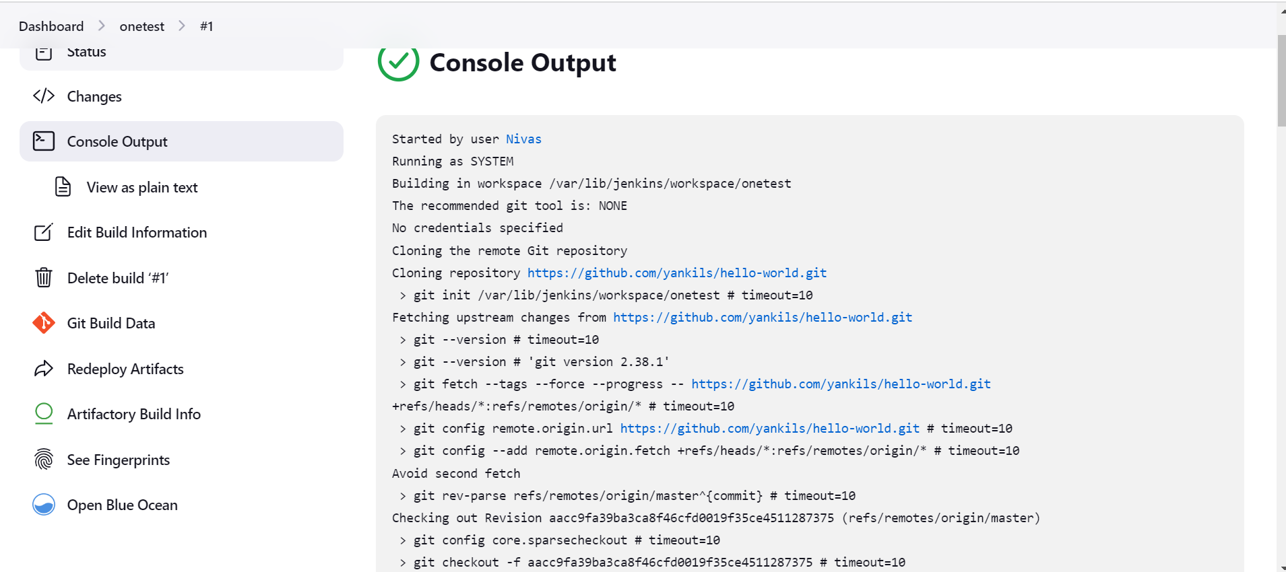

1. **The Build process is getting succeed.**